**COLLEGE OF APPLIED BUSINESS AND TECHNOLOGY**

**Kathmandu, Nepal**

**(Affiliated to Tribhuvan University)**

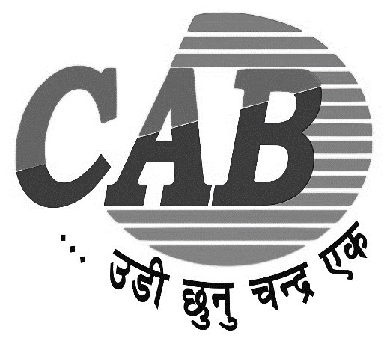

**E-GOVERNANCE PROJECT REPORT**

**ON**

**ONLINE COMPANY REGISTRATION**

**Submitted by:**

Az Kafle (106)

College of Applied Business and Technology

B.Sc.CSIT 6th Semester

**Submitted to:**

Mr. Tekendra Nath Yogi

July, 2024

Organization Certification

This is to certify that the case study report on “Office of The Company Registrar e-Services” has been completed under the guidance of Mr. Tekendra Nath Yogi and submitted by AZ Kafle for partial fulfillment of the requirements for the Bachelor’s Degree in Computer Science and Information Technology

Supervisor Declaration

I certify that the case study report titled “Office of The Company Registrar e-Services” has been completed by AZ Kafle under my supervision. This report is original and has been prepared following the guidelines of College of Applied Business and Technology.

To the best of my knowledge, this work is the student's own and has not been submitted for any other degree or diploma.

Mr. Tekendra Nath Yogi

Department of Computer Science and Technology

College of Applied Business and Technology

Date: 2081/03/02

Signature: ……………….

Student Declaration

I, AZ Kafle, declare that this case study report titled “Office of The Company Registrar e-Services” is my original work and has been completed in accordance with the guidelines provided by College of Applied Business and Technology.

I confirm that this report has not been submitted, either wholly or partially, for any other degree or diploma at any other university or institution.

AZ Kafle

B.Sc. CSIT 6th Semester

College of Applied Business and Technology

Date: 2081/03/02

Acknowledgment

I would like to express my deepest gratitude to Mr. Tekendra Nath Yogi, whose guidance, support, and encouragement made this case study possible. Your invaluable insights and feedback have been instrumental in the completion of this report.

The access to Office of The Company Registrar e-Services platform was crucial for the successful completion of this study.

Lastly, I extend my gratitude to College Of Applied Business and Technology for providing a conducive learning environment and the opportunity to undertake this case study.

AZ Kafle

2081/03/02

# Abstract

This case study examines the implementation and effectiveness of the OCR e-Services platform in Nepal, focusing on the new company registration process. The study outlines the steps involved in user account creation, company name reservation, and the submission of the company registration form. It evaluates the strengths and weaknesses of the current system, identifies potential opportunities for improvement, and highlights threats that could impact its success.

The findings reveal that the OCR e-Services platform significantly streamlines the registration process, reducing paperwork and the need for physical visits to the Office of Company Registrar. Key strengths include a user-friendly interface and efficient name reservation system. However, the study also identifies several weaknesses, such as the initial user registration challenges and the dependence on reliable internet connectivity. Overall, the OCR e-Services platform represents a significant advancement in e-governance in Nepal, promoting a more efficient and transparent business registration process.

# Table of Contents

Abstract i

Table of Contents ii

List of Figures iii

List of Abbreviations iv

Chapter1 1

Introduction 1

Objective 2

Scope 3

Report organization 4

Chapter 2 5

Organization introduction 5

**History and Establishment 5**

**Evolution of Company Law 5**

**Vision 5**

**Concept 5**

**Aim 6**

**Major Functions 6**

E-governance in the organization 8

Chapter 3 9

Strengths 9

Weaknesses 10

Opportunities 10

Threats 11

Chapter 4 12

Conclusion and Recommendations 12

References 13

Appendix 14

# List of Figures

**Figure 1: Login Page 14**

**Figure 2: Create User Form 14**

**Figure 3: Login into the OCR-eService (for the first time after receiving Login Details in mail) 15**

**Figure 4: Name Reservation Request Form 15**

**Figure 5: Company Registration Form 16**

# List of Abbreviations

* OCR: Office of Company Registrar
* NSIC: National Small Industries Corporation
* SWOT: Strengths, Weaknesses, Opportunities, and Threats

# Chapter1

## Introduction

Registering a new company is a crucial step for entrepreneurs and business owners in Nepal. Traditionally, this process has been time-consuming and complex. To address these challenges, the Office of Company Registrar (OCR) in Nepal introduced the OCR e-Services platform. This online platform aims to simplify and streamline the company registration process, making it more accessible, efficient, and user-friendly.

**Key Points:**

**OCR e-Services Platform:** Part of Nepal's e-governance initiative aimed at improving public service delivery.

**Digital Transformation:** Transition from paper-based methods to an online system to enhance transparency and efficiency.

**Focus:** The case study focuses on user account creation, company name reservation, and company registration form submission.

**Benefits:** Reduced paperwork, elimination of physical visits, and a more efficient registration process.

**Challenges:** Identifies initial user registration challenges and reliance on internet connectivity.

**Recommendations:** Includes suggestions for improving user experience, cybersecurity, and expanding services.

## Objective

The primary objective of this case study is to evaluate the OCR e-Services platform's new company registration process in Nepal. Specifically, the study aims:

* **To Understand the User Registration Process on the OCR e-Services Platform:**
* **Detailing the Process:** This includes the steps from initial account creation to verification, login procedures, and accessing the registration services.
* **Evaluating User Experience:** Understanding the user experience during the registration process.
* **Assessing Interface Design:** Evaluating the design and usability of the user registration interface.
* **To Identify the Strengths, Weaknesses, Opportunities, and Threats of the System:**
* **Strengths:** Identifying the positive aspects of the OCR e-Services platform that contribute to its effectiveness and user satisfaction in Nepal.
* **Weaknesses:** Highlighting areas where the platform may fall short or where users face difficulties.
* **Opportunities:** Exploring potential improvements and enhancements.
* **Threats:** Assessing potential risks and challenges that could negatively impact the platform.

## Scope

This case study focuses on the new company registration process facilitated by the OCR e-Services platform in Nepal. The scope of this study encompasses the following key areas:

1. **User Account Creation:**
   * **Process Overview:** the steps required to create an account on the OCR e-Services platform.
   * **User Experience:** Evaluation of the user interface and experience during account creation, including any challenges faced by users in Nepal.
   * **Verification Procedures:** Analysis of the verification methods used to authenticate new users and ensure the security of the registration process.
2. **Company Name Reservation:**
   * **Procedure Description** analysis of the name reservation process
   * **System Efficiency:** Assessment of the efficiency and reliability of the name reservation system, including the speed and accuracy of processing requests.
3. **Company Registration Form Submission:**
   * **Form Structure:** examination of the company registration form, including the required fields, documentation, and overall design.
   * **Submission Process:** Analysis of the process for submitting the completed registration form, including any potential barriers or issues faced by users.
4. **Strengths, Weaknesses, Opportunities, and Threats (SWOT) Analysis.**

The study does not cover other services provided by the OCR e-Services platform outside of the new company registration process. Additionally, the focus is on the practical application and user experience of the platform, rather than the technical development or backend infrastructure.

## Report organization

The report is organized into 5 chapters, each of which discusses a different aspect of the project, from the introduction and objectives to the SWOT analysis and recommendations for future work.

**Chapter 1: Introduction**

* This chapter introduces the OCR e-Services platform for new company registration in Nepal.
* It includes the problem statement, objectives, and scope of the study.
* Provides an overview of the significance of e-governance in Nepal.

**Chapter 2: Organizational Overview**

* This chapter provides background information on the Office of Company Registrar (OCR) in Nepal.
* Discusses the mission, vision, and role of OCR in company registration.
* Describes the e-governance initiatives undertaken by the OCR, with a focus on the digital transformation of company registration services.

**Chapter 3: Strengths, Weaknesses, Opportunities, and Threats (SWOT) Analysis**

* This chapter conducts a SWOT analysis of the OCR e-Services platform.

**Chapter 4: Conclusion and Recommendations**

* This chapter summarizes the main findings of the case study and includes references and supplementary materials.
* Provides practical recommendations for improving the OCR e-Services platform, such as simplifying user registration, enhancing cybersecurity measures, and offering comprehensive user support.
* **References:** Lists all sources and references used in the preparation of the case study report.
* **Appendix:** Contains supplementary materials such as sample user registration forms, name reservation request forms, and company registration forms.

# Chapter 2

## Organization introduction

### History and Establishment

The Office of the Company Registrar (OCR) is a department-level office established in January 2049 under the Ministry of Industry in Nepal. Prior to its establishment, company administration activities were managed by various agencies, including the Department of Industry, Department of Commerce, Department of Cottage and Small Industries, and the Department of Agriculture. The creation of the OCR aimed to bring uniformity in the application and compliance with the Company Act, consolidating all activities related to company administration under a single agency. To further extend its services, OCR has established two regional offices in Itahari and Butwal.

### Evolution of Company Law

The history of the Company Act in Nepal dates back to 1993, marking the beginning of formal company legislation. Over the years, the Company Act has undergone several revisions and updates to better align with the evolving business environment and regulatory needs:

* **Company Act 2021 B.S.**
* **Company Act 2053 B.S.**
* **Company Ordinance 2062 B.S.**
* **Company Act 2063 B.S.** (currently in implementation)

### Vision

The vision of the OCR is to provide easy and effective services to the founders and shareholders of companies, ensuring a supportive environment for business operations in Nepal.

### Concept

The OCR operates on several key concepts to enhance its service delivery:

* **Efficiency and Effectiveness:** The OCR aims to provide fast, efficient, and effective services to newly registered companies.
* **Compliance Monitoring:** It monitors necessary activities and documents in accordance with the Companies Act.
* **Information Accessibility:** The OCR makes company-related information and documents available to relevant parties, general members, and stakeholders.
* **Challenges Resolution:** It aims to address and solve challenges in the field of company administration clearly and effectively.

### Aim

The primary aim of the OCR is to facilitate the registration and operation of companies in accordance with the Company Act, which provides the framework for conducting business and raising capital based on limited liability. The OCR supports industrial and commercial promotion, financial and legal discipline, and the development of the capital market.

### Major Functions

The OCR performs a wide range of functions as specified by the Companies Act, 2063, including:

* **Company Registration:** Registers private limited, public limited and not-for-profit companies.
* **Record Keeping:** Checks and maintains records before publishing details of public limited companies.
* **Amendments and Changes:** Manages the increase in share capital, changes in company names, and amendments to articles of association and regulations.
* **Monitoring and Investigation:** Monitors registered companies for compliance with the Companies Act and appoints inspectors as necessary.
* **Consultations and Opinions:** Provides opinions and consultations regarding the Companies Act.
* **Liquidation:** Manages the liquidation of companies as per the Companies Act.
* **Compliance Enforcement:** Takes action on complaints of shareholders and other violations of the Companies Act.
* **Merger Management:** Handles company mergers as per legal requirements.
* **Regulatory Actions:** Orders the filing of prescribed details, notices, and information within stipulated times, and imposes fines and deregistrations for non-compliance.
* **Government Instructions:** Carries out additional tasks as instructed by the Government of Nepal, including acting as the regulator of trust and company service providers and managing insolvency cases.

## E-governance in the organization

The Office of the Company Registrar (OCR) in Nepal has embraced e-governance as a means to improve the efficiency and accessibility of its services. The OCR e-Services platform is a significant step in this direction, providing a comprehensive online solution for company registration. This initiative aligns with the broader goals of the Nepalese government to leverage technology in enhancing public service delivery.

The e-Services platform simplifies the company registration process by:

* **Reducing paperwork**: Transitioning to digital forms and online submissions minimizes the need for physical documents.
* **Streamlining processes**: Automating workflows to reduce time and effort required for registration.
* **Enhancing accessibility**: Making services available online ensures that users can access them from anywhere, at any time.
* **Improving transparency**: Digital records and processes increase transparency and accountability.

# Chapter 3

## Strengths

The OCR e-Services platform has several strengths that make it an effective tool for company registration:

* **User-Friendly Interface:** The platform is designed with an intuitive interface, making it easy for users to navigate through the various stages of company registration. Clear instructions and helpful prompts guide users through the process.
* **Streamlined Registration Process:** The digital nature of the platform reduces the administrative burden, cutting down the time and effort required to register a company. This efficiency helps in faster processing of applications.
* **Reduced Paperwork and Physical Visits:** The transition to an online system eliminates the need for physical documentation and in-person visits, which were previously necessary. This not only saves time but also reduces the logistical challenges for applicants.
* **Quick Name Reservation System:** The platform includes a feature that allows users to quickly check the availability of and reserve company names, ensuring that the desired name can be secured without delay.

## Weaknesses

Despite its strengths, the OCR e-Services platform also has some weaknesses:

* **Cumbersome Initial Registration:** The initial registration process can be complex for some users, particularly those who are not tech-savvy. This can create a barrier to entry for new users who may find the digital forms and procedures intimidating.
* **Dependence on Internet Connectivity:** Reliable internet access is a prerequisite for using the platform. This can be a significant hurdle in areas with poor internet infrastructure, limiting the platform’s accessibility.
* **Limited Support for Non-Digital Users:** The platform may not adequately cater to individuals who are uncomfortable with or lack access to digital technologies. This digital divide can exclude a segment of the population from accessing the services efficiently.
* **Site is unreachable during Public holidays**

## Opportunities

There are several opportunities to further enhance the functionality and reach of the OCR e-Services platform:

* **Expanding Services:** The platform can be expanded to include additional services such as business license renewals, annual filings, and other regulatory compliances. This would provide a one-stop solution for various company-related needs.
* **Integration with Other Government Services:** Linking the OCR e-Services platform with other government databases and services can streamline processes further. For example, integration with tax authorities, social security systems, and other regulatory bodies can create a more interconnected and efficient service environment.
* **Enhancing User Support:** Providing additional resources such as tutorials, FAQs, and customer support can help users navigate the platform more effectively. Live chat support and helpline services can assist users in real-time, improving their overall experience.

## Threats

The OCR e-Services platform faces potential threats that need to be addressed to ensure its sustained effectiveness:

* **Cybersecurity Risks:** As an online platform handling sensitive company information, it is vulnerable to cyber-attacks and data breaches. Ensuring robust cybersecurity measures is crucial to protect user data and maintain trust.
* **Technical Issues and Downtime:** Any technical glitches or system downtimes can disrupt the registration process, leading to delays and user dissatisfaction. Regular maintenance and prompt resolution of technical issues are essential.
* **Resistance to Change:** Some users and stakeholders may be resistant to transitioning from traditional paper-based methods to digital platforms. Addressing this resistance through awareness programs and demonstrating the benefits of the digital platform can help in smoother adoption.

# Chapter 4

## Conclusion and Recommendations

**Conclusion**

The OCR e-Services platform for new company registration in Nepal represents a significant advancement in the realm of e-governance. By digitizing the registration process, it has enhanced accessibility, efficiency, and transparency, making it easier for businesses to comply with regulatory requirements.

**Recommendations:**

* **Simplify User Registration:** Streamlining the initial user registration process by reducing the number of steps and providing clear, step-by-step instructions can help lower the barrier for new users.
* **Enhance Cybersecurity:** Implementing advanced cybersecurity measures, including regular security audits and user awareness programs, is crucial to safeguard the platform against potential threats.
* **Provide Comprehensive User Support:** Offering robust support and training resources, such as video tutorials, detailed FAQs, and dedicated customer support, can help users navigate the platform more effectively.
* **Expand Services:** Including additional services like business license renewals and annual filings can enhance the platform’s utility and provide a comprehensive solution for businesses.
* **Integrate with Other Services:** Linking the platform with other government databases and services can streamline processes and create a more efficient service environment.
* **Address Resistance to Change:** Conducting awareness and training programs can help users understand the benefits of the digital platform, addressing any resistance to moving away from traditional methods.
* **Availability of Services:** Instead of shutting down the Site during public holidays. It is better to inform that the e-service is unavailable in Home page. But it is necessary that the e-service should available 24/7.

## References

* [Office of The Company Registrar (ocr.gov.np)](https://www.ocr.gov.np/page/1_5e2736171bccc)
* [Online Company Registration (ocr.gov.np)](https://camis.ocr.gov.np/register)
* OCR e-Services (Office of Company Registrar Online Services) User Manual!: <https://application.ocr.gov.np/faces/OnlineUserLogin.jsp>
* RAUNIAR, A., & MAGALHAES, N. (2012). A New, Improved Office of Company Registrar in Nepal.

## Appendix

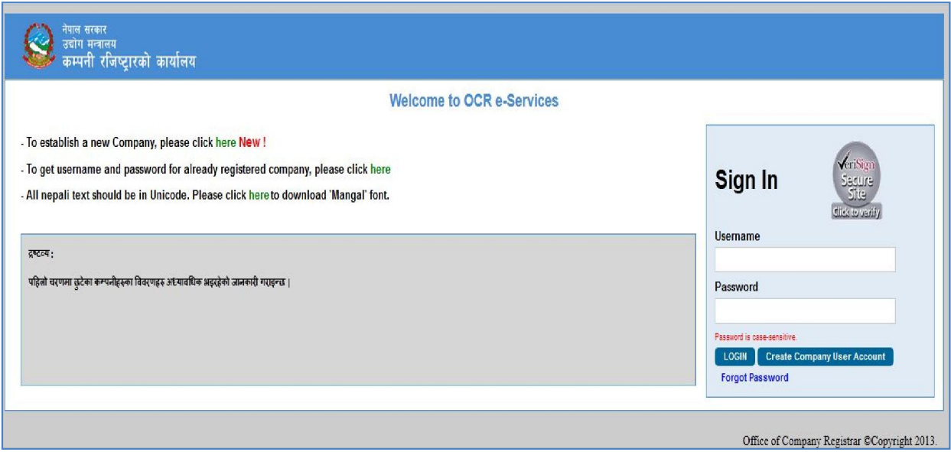

Figure : Login Page

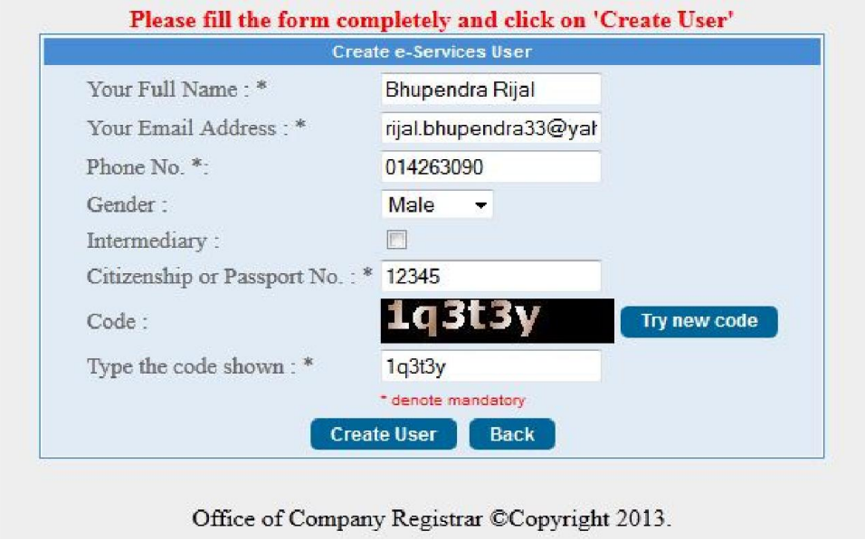

Figure : Create User Form

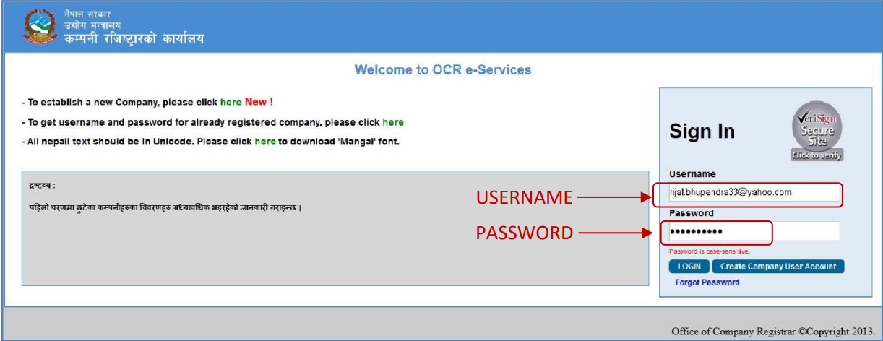

Figure : Login into the OCR-eService (for the first time after receiving Login Details in mail)

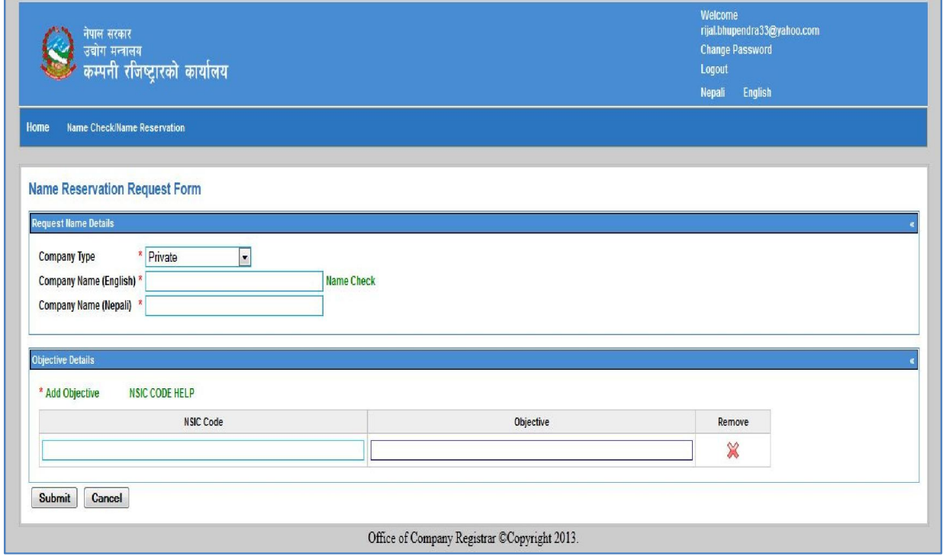

Figure : Name Reservation Request Form

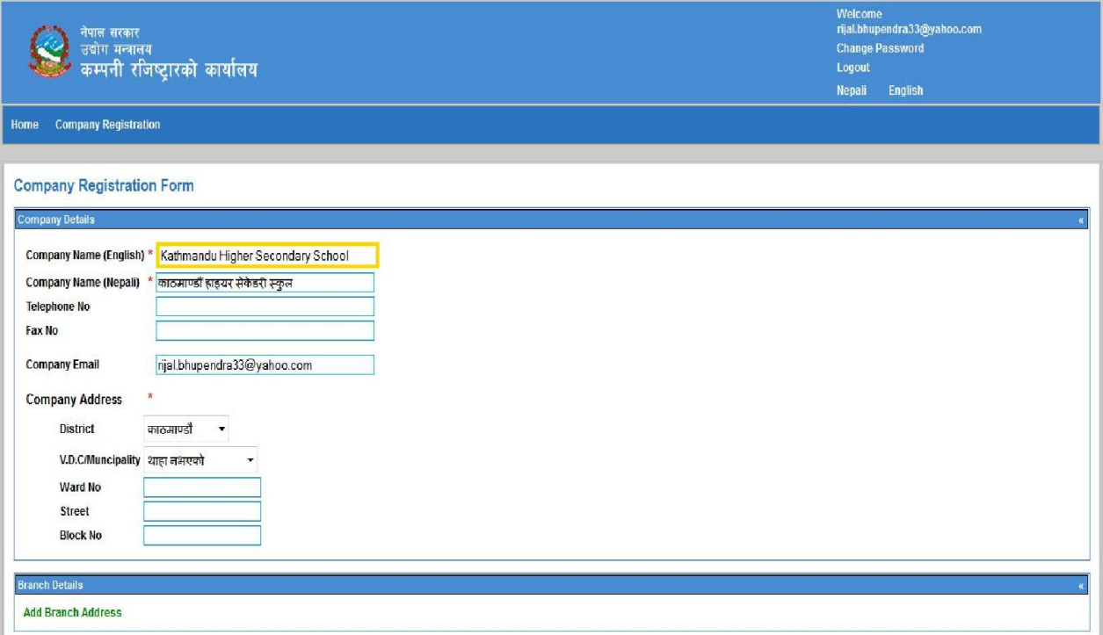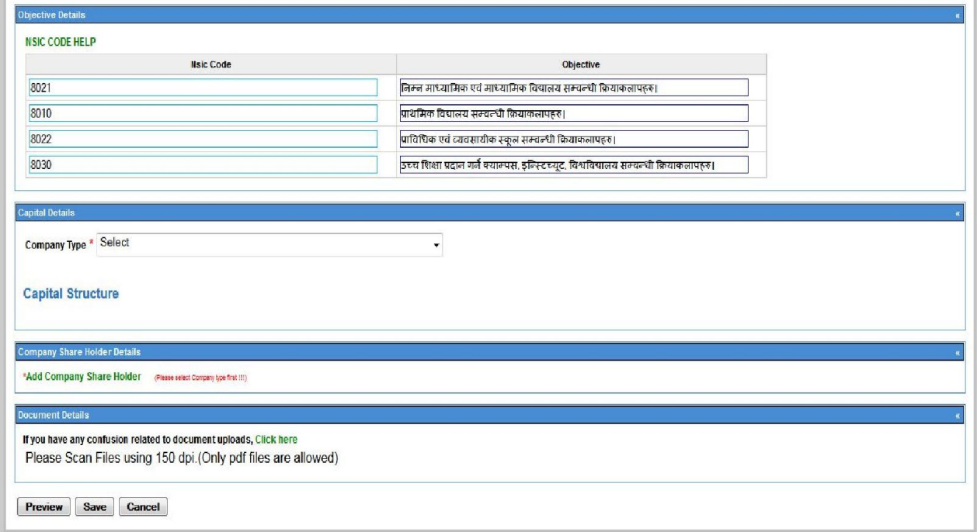

Figure : Company Registration Form

**Chapter 3: Analysis of the OCR e-Services Platform**

* This chapter details the user account creation process, including user experience, interface design, and verification procedures.
* Analyzes the company name reservation procedure, highlighting steps, challenges, and system performance.
* Examines the company registration form submission process, focusing on form structure, compliance with regulations, and user feedback.